Year 5 English Examination Revision Guidance – 2020
45 minutes
Reading Comprehension

Part One: Literary Comprehension
Boys are given an 11+ exam-style paper featuring a passage from, for example, story, autobiography, report etc. Questions seek to test understanding as well as power of analysis and evaluation. Passages are selected without any standard pattern, in order to encourage a variety of approaches to the reading of quality literature.
Skills to be tested as the appropriate level include the following:
  - Basic understanding and vocabulary
  - Use of text to illustrate answers
  - Drawing of inferences
  - Evaluation of language
  - Delivery of opinions / judgments / arguments based on given material
  - Awareness of how grammar, sentence structure and punctuation affect meaning
  - Identifying literary techniques

In this comprehension paper, the examiner is looking to test you on:

- Your vocabulary skills - do you know what the words mean and can you explain that meaning in a sentence?
- Your evidence skills. Can you prove your answer is correct by using a quote and explaining it?
- Your inference skills. This is when the answer is not in the text. Can you work out for yourself what the answer is, even if there is not a quote, and give a convincing reason?

- Can you comment on and discuss the style, language and purpose? For example – why is the writer using an informal style? How does this affect how you read the piece? Why has the writer picked this word, or used these words and phrases twice? What is the point of this piece of writing – what is it trying to achieve - who is it aimed at?
- Can you provide answers which: back up your opinions with solid evidence and create a convincing argument? You need solid evidence to put forward your point, provide the evidence (proof), in the form of a quote from the text, and finally, explain how your quote proves that your point is true. This process creates a convincing and believable answer.

Reading the text
- Anticipate the questions. When you read through the passage or the poem, try to think what questions might come up. Pick out the words or phrases you think the examiner will have selected for questions. Try to spot which technical aspects of the piece will be explored in the higher mark questions. Then, by the time you reach the exam questions, you might have already worked out some of the answers.
- Scribble, underline and write notes all over the paper. If you spot words, phrases or quotes you think will be worth using later – highlight or ring them. Don’t be afraid to write notes on the question paper.

  - How many answers are required? If the question asks for three responses, and six marks are on offer, it is safe to assume that three reasons, each with one piece of evidence (a quote) and explanation are required. Use the marks details to work out how many reasons, pieces of evidence and explanation you need to provide.
  - ‘In your own words’ questions catch boys out every year. You will not earn marks for quoting the text here. Paraphrase or summarise using alternative words.
  - The ‘what do you think’ and ‘why’ question. Normally there’s a 3-5 mark question asking for your views backed by reason and evidence (quotes). It’s often the last question on the paper. The marks scheme often tells the teacher to give marks for “any reasonable response”. Therefore so long as your answer is largely correct and convincing, it will gain marks.
45 minutes
Creative Writing

Part Two: Creative Writing
Boys are required to answer one question from a range of options which includes narrative, descriptive and imaginative writing. Candidates are expected to demonstrate, within the confines of an examination, the full range of their writing ability in their chosen form. They are expected to demonstrate their ability to use correct spelling, punctuation, grammar and syntax and to adapt their writing appropriately to their chosen task.

- Descriptive – describing an event, scene, memory. Whatever you chose to write about do not write a story. If the question asks for a description! Focus very specifically on exactly what the question asks for. Use figurative language (imagery) and powerful verbs to enhance your description. Frame your descriptions: perhaps describe a room from side to side or up and down. Use a telescope technique to zoom right out in an opening paragraph and then progressively zoom in with each subsequent paragraph, or vice versa. Have a method to your description – avoid a random series of images.
- Narrative Titles– a story. Plan effectively. Ensure you have a structure. Perhaps use a five act plan – a setting, a problem, build up, climax, resolution. Or start in the middle of the action for something different and exciting. Above all, know what you are going to write before you start writing. When describing, especially for scene setting, use figurative language (imagery) and powerful verbs to enhance your use of language.
- Picture Prompts – The exam may give boys a picture to use as a prompt for writing. ‘Write in any way you wish about this picture’ is a common task. A narrative story or vivid description are common expectations here.
- Paragraphing is essential. Boys cannot achieve any more than 50% if they do not have paragraphs.
- Revisit your English book to identify targets and next steps. Identify what went well and aim to repeat this success in the exam. Look for what required improvement and add to your compositions in the exam.
- Check out Mr Thorne’s grammar videos to help you revise: https://www.youtube.com/playlist?list=PL49586F62799A527D

Creative Writing Tips:
- Read all the options through a couple of times.
- Remember to select your title carefully and write to your strengths.
- Write a brief plan for your 5 for 6 paragraph piece.
- Opt for an unusual and engaging opening.
- Find opportunities to use similes, metaphors, personification and sensory description in your writing.
- Remember to use variety in your sentence openings and sentence structure.
- Keep in the same tense throughout.
- Use sophisticated vocabulary and avoid repetition.
- Think ‘outside the box’ when looking at the titles. Try to be original!
- Avoid blood, death, zombies, guns, Ferraris – these are clichés and unlikely to be original.

Note from Mr Thorne: Most importantly of all, remember that exams are just a ‘snapshot’ of what you can do at one point in time. Your industrious work throughout the year is noticed by your teachers and we are always looking at the bigger picture: your progression in English from September through to July.

We want you to achieve your optimum; show off what you can do.

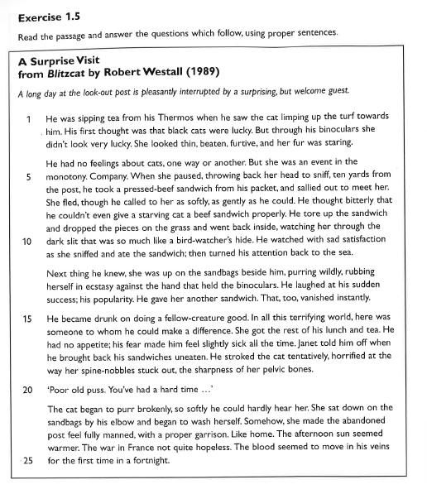

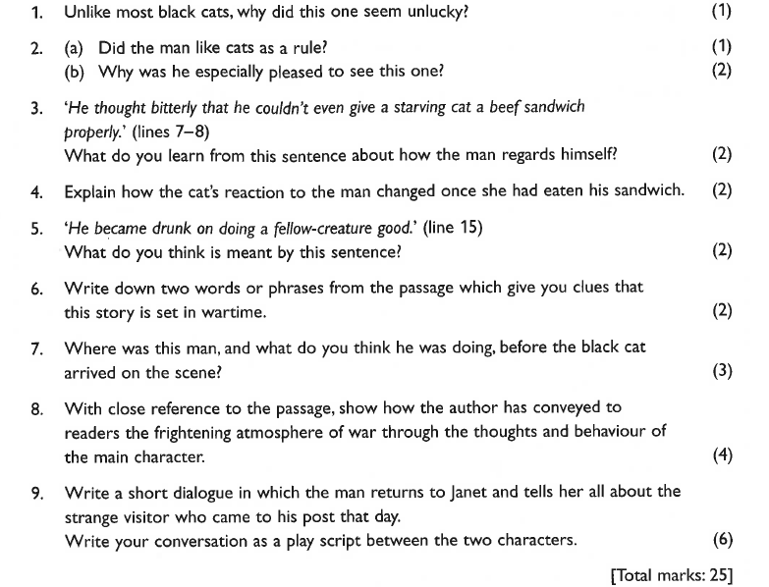
MARK SCHEME

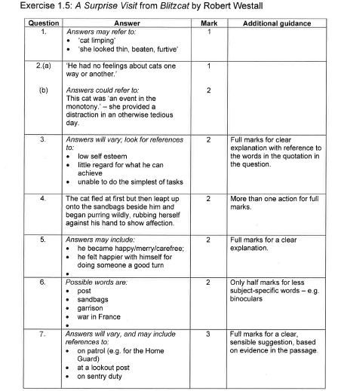

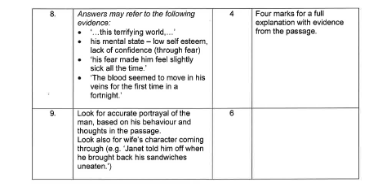

Writing Task Sample:
Write a story using one of the following titles or beginnings:
- Three Wishes
- Room 1001
- The candlelight flickered and extinguished; that was when it all began.

Or write in any way you wish about the picture below: (this appears open-ended but stick to the tried and tested formula of a story or a paragraphed description.)

